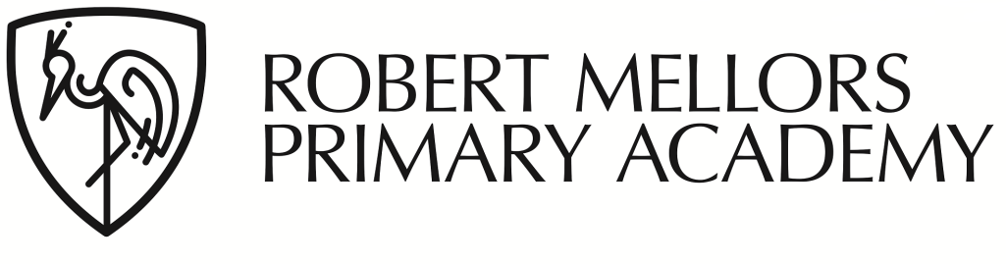

20th July 2023

Dear Parents and Carers

Information for children going into Year 3 September 2023:

When your child goes into Year 3 in September they will no longer be eligible for Universal Free School Meals. **This means that unless your child is on the Free School Meal list, you will have to pay for school dinners. These are charged at £2.58 per meal and must be paid in advance on your ParentPay account.** If you haven’t activated your ParentPay account yet then please contact the office and we will give you all the details you need.

**If you think you might be entitled to Free School Meals then please let us have your email address and we will send you a link to apply online.**

**All meals must be paid for on ParentPay and booked in advance at the school office**. **Meals for children on the FSM list must also be booked in advance at the office.** This is really important, as it allows us to cater for the right amount of children. If you would like your child to swap from packed lunches to dinners or vice versa during the term then you must let the office know in advance.

Many thanks

Miriam Wong

0115 8408068