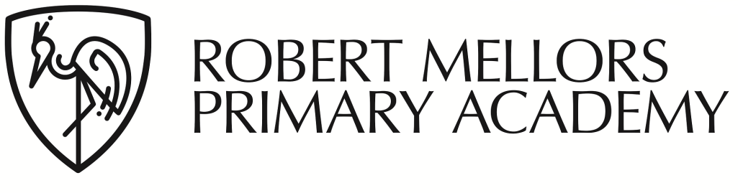

## Bonington Drive, Arnold,

## Nottingham

## NG5 7EX

## Tele: 0115 8408068

## Fax: 0115 8408708

## Head Teacher: Mrs E Essex

## Email: office@robertmellors.org.uk

Dear Parents and Carers,

**Re: Increase to school meal cost**

We have been told by the Local Authority that they have recently undertaken a price review of school meals. From 16th October 2023, the price of a school meal will be £3 per meal. This will be updated on ParentPay from that date.

Please note that all children in F2, Y1 and Y2 will continue to be eligible for Universal Free School Meals, as will children on our benefits-related Free School Meal list (for families in receipt of qualifying benefits).

The information we received from NCC was as follows: *‘Catering Services have been subject to significant inflationary pressures over the previous 12 months, with significant upward pressures on labour and food costs. The Service has continued to work hard to minimise the impact of these cost pressures on our charging regime for schools for this year, as we recognise the financial pressures faced across the education sector.’*

We want to make it clear that this cost increase has been imposed by the Local Authority, it is not a decision that we have made in school.

If any of you think your child may be entitled to Free School Meals, it is definitely worth applying. It is easy to apply and you will get an instant answer. Free meals cannot be back-dated so please apply as soon as possible.

Apply online at:

<https://www.nottinghamshire.gov.uk/education/school-meals/free-school-meals-and-milk>

Or call: 0300 5008080

If your claim is successful please let the school office know so we can update our system.

Kind Regards,

Miriam Wong

