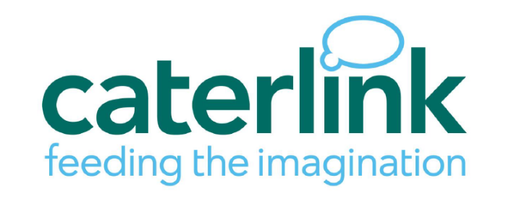

Exciting update to Robert Mellors school meals!

Dear parents and carers,

We’re really happy to announce that **from April** we’ll be moving over to Caterlink as our new meals provider. Caterlink are specialist caterers to the education sector and all meals will be freshly cooked here in the Robert Mellors kitchen.

Healthy eating is at the very heart of Caterlink’s approach to food. They wholeheartedly encourage

a balanced diet and use a range of seasonal produce from local and regional suppliers.

Caterlink will be offering a choice menu, which means your child will be able to choose from a range

of tasty meal options each week. Some of the meals we have seen so far on the new menu include roast dinners, spaghetti bolognaise, all day breakfast, jacket potatoes, Thai green curry, smoky bean burgers and much more. Pudding options include lemon cake, peaches and ice cream, pear and cocoa upside down cake and apple flapjack – yum!

Because of this new choice menu, FROM APRIL 22nd **ALL MEALS** WILL NEED TO BE ORDERED ONLINE IN ADVANCE.We will be using a meal booking system on ParentPay, so if you don’t already have a ParentPay login, please contact the school office now so that we can set you up with an account.

**If you do not order your child’s meals in advance you will need to provide them with a packed lunch, so make sure you go through each week’s menu at home with your child – perhaps you could set an alarm as a weekly reminder.**

We will be putting the new menus on our website soon, and we’ll send further instructions on how

and when to order meals on ParentPay. You don’t need to do anything differently yet, but we wanted to share the news with you all.

*Please note - We’re working towards having the ParentPay ordering system go live over Easter, for you to book meals in advance of us coming back on the 22nd April. For the last four days before the Easter break (Tues 1st – Fri 4th April), Caterlink will be providing jacket potatoes and sandwiches for all children having school meals while we transition over to the new menu.*

Kind Regards,

RMPA